Module 5 Critical Thinking Assignment: Weekly Temperatures Using Decision Control Structures and Arrays Option 1

Grant Brosovich

CSU-Global

CSC320-01

Dr. Terrell Brandes

April 20, 2025

**Pseudocode:**

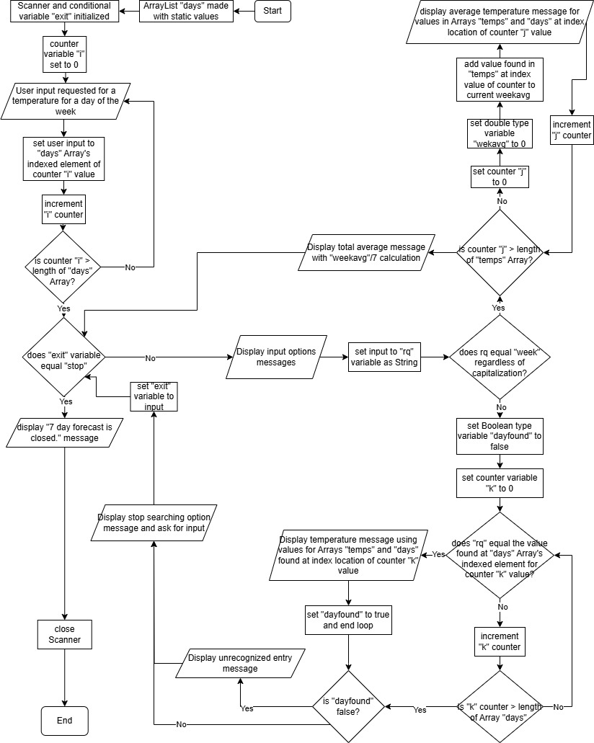

**Source code:**

**import** java.util.Scanner;

**public** **class** WeeklyTemp {

**public** **static** **void** main(String[] args) {

String[] days = {"Monday", "Tuesday", "Wednsday" , "Thursday", "Friday", "Saturday", "Sunday"};

**int**[] temps = **new** **int**[7];

//Kept as standard Array for consistency in length

Scanner sc = **new** Scanner(System.***in***);

String exit = "go";

**for**(**int** i = 0; i < days.length; i++) {

System.***out***.println("Please enter an average temperature for " + days[i] + ".");

temps[i] = sc.nextInt();

sc.nextLine();

}

**while**( !exit.equalsIgnoreCase("stop")) {

System.***out***.println("To display an average temperature for a single day of the week, enter the day of the week to search for");

System.***out***.println("To display the entire week's averages, please enter \"week\".");

System.***out***.println("Enter your request now:");

String rq = sc.nextLine();

**if** (rq.equalsIgnoreCase("week")) {

**double** weekavg = 0;

**for** (**int** j = 0; j < temps.length; j++) {

weekavg = weekavg + temps[j];

System.***out***.println("The average temperature for " + days[j] + " is " + temps[j] + ".");

}

System.***out***.println();

System.***out***.println("The average temperature for the week is " + (weekavg / 7)+ ".");

} **else** {

**boolean** dayfound = **false**;

**for** (**int** k = 0; k < days.length; k ++) {

**if** (rq.equalsIgnoreCase(days[k])) {

System.***out***.println("The average temperature for " + days[k] + " is " + temps[k] + ".");

dayfound = **true**;

**break**;

}

}

**if** (!dayfound) {

System.***out***.println("That entry was no recognized. please try again");

}

}

System.***out***.println("\nTo stop searcing please enter \"stop\". Otherwise, make any entry to continue");

exit = sc.nextLine();

}

System.***out***.println("7 day forecast closed.");

sc.close();

}

}

**Running application screenshots:**

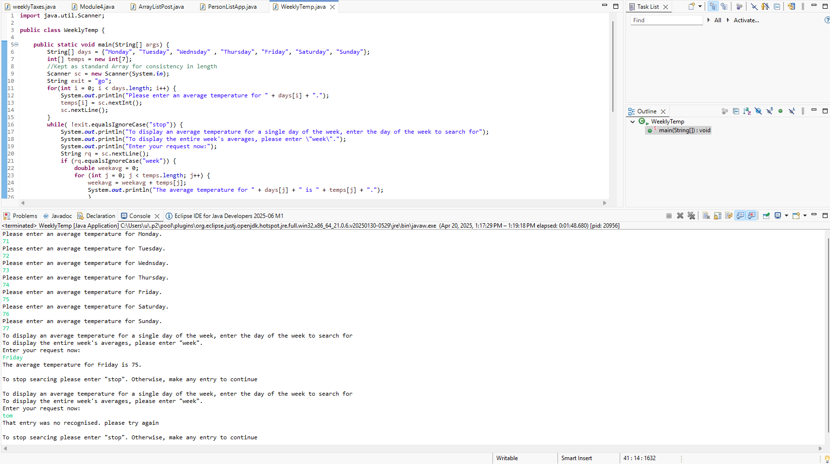

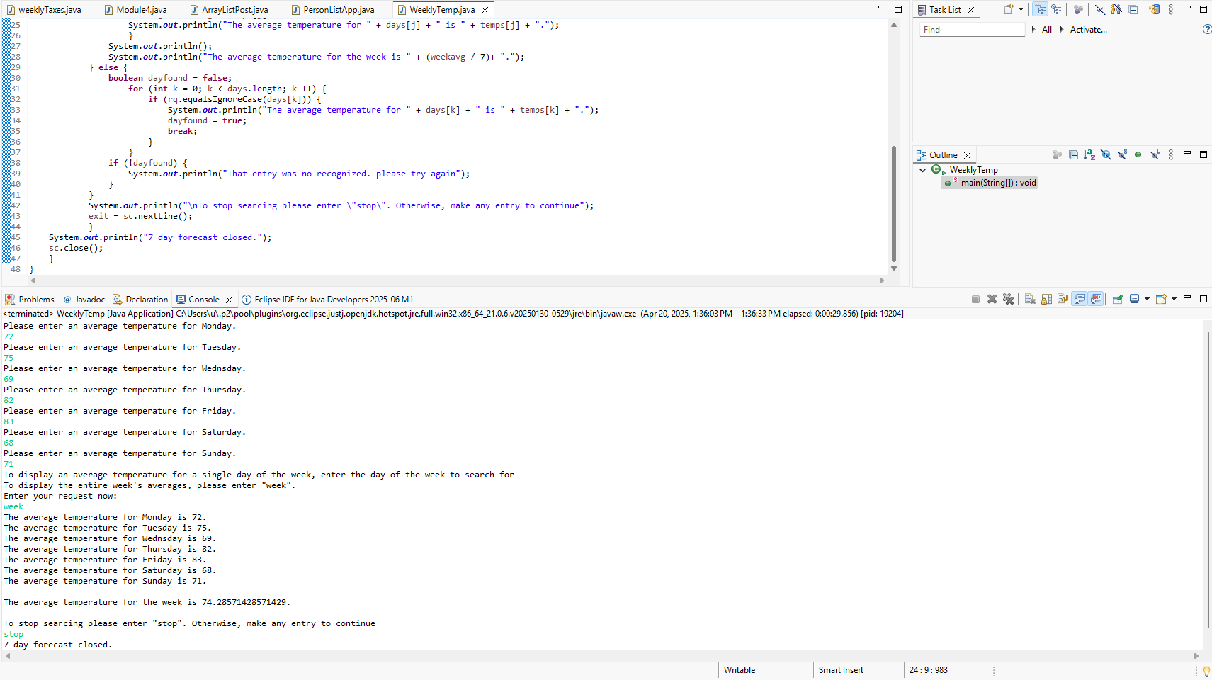

**Link to GitHub repository for Module 4 Critical Thinking Assignment:**

<https://github.com/GrantBros/Module5>

All the files are located in the Module5 folder of the Github repository in their original format.